 | IQVIATM Work Instruction  Creation, Conversion or Revision of Structured Product Labeling in the US
Document Number and Revision:
CS_WI_RA0307 Revision 1
Document Owner:  Mariana Cupo | Author(s):  Sowjanya Chitturi

PURPOSE
This Work Instruction (WI) describes the process for creation, conversion and /or revision of documents in Structured Product Labeling (SPL) format prior to submission to the United States (US) Food and Drug Administration (FDA).

SCOPE
This work instruction applies to all staff within Regulatory Affairs & Drug Development Solutions (RADDS) working on creation, conversion or revision of SPL.
This WI is applicable to Content of Labeling (CoL), Drug Establishment Registration (ER), GDUFA (Generic Drug User Fee Act), Self-Identification (SID), Labeler Code Request (LCR), Bulk Drug listing (Bulk DL), Product Drug listing (DL), and Lot Distribution Report (LDR).
This WI does not apply outside of the US or to other SPL document types.

ROLES AND RESPONSIBILITIES
The following roles perform tasks described within this WI:

Role | Sections
Project Team Member (PTM) | 6.1.4, 6.1.5, 6.1.6, 6.2.2, 6.4.1,  6.5.1, 6.8.1
Global Labeling Lead (GLL) | 6.1.1, 6.1.2, 6.1.3, 6.2.1, 6.4.1,  6.5.1, 6.8.1
SPL Specialist | 6.3.1
Regulatory Lead (RL) | 6.1.7, 6.1.8, 6.3.1, 6.3.2, 6.6.1,  6.7.1,

DEFINITIONS
Content of Labeling (CoL): The prescription drug labeling described in 21 CFR 201.100(d) which must contain the information as specified in §§201.56, 201.57, and 201.80, including all text, tables, and figures (commonly referred to as the US PLR or professional labeling) and includes the patient labeling, Medication Guide (if applicable), and Instructions for Use (if applicable). It does not include carton or container labels. Creation, conversion and/or revision requests with SPL Specialist require the IQVIA Labeling and Listing Form (IQVIA-LLF) (CS_FM_RA0310).

Establishment Registration (ER): All registrants (see §207.1) must register each domestic establishment that manufactures, re-packs, re-labels or salvages a drug, and each foreign establishment that manufactures, re-packs, re-labels, or salvages a drug, that is imported or offered for import into the US. ERs must be renewed annually between October 1 and December 31. Requires the IQVIA Establishment Registration Form (IQVIA-ERF) (CS_FM_RA0309).
Self-Identification: All registrants (see Public 19 Law 112-144, Title III) must self-identify the facilities, sites and organizations related to a generic drug submission with FDA. Self- identification must take place annually between May and June. Requires the IQVIA Self Identification Form (IQVIA-SIDF) (CS_FM_RA0312).
Initiator: The individual listed in the Contact Information section of the SPL request form.
Labeler Code Request (LCR): A submission to the FDA to obtain an initial labeler code or when information (see §207.33) relating to the labeler code changes. Requires the IQVIA-Labeler Code Request Form (IQVIA-LCRF) (CS_FM_RA0313).
Blanket No Change Certification: All registrants (see §207.29 (b)) should submit “blanket no change certification” for all drug product listings that required no updates within the year. BNCC must be submitted annually between October 1 to December 31 renewal period for products that do not require any updates. Requires the IQVIA Blanket No Change Certification Form (IQVIA-BNCCF) (CS_FM_RA0311).
Marketing End Date: The expiration date in YYYYMMDD format of the last product lot distributed. Products that are actively being marketed will not have a marketing end date. Products that are no longer manufactured may have a future end marketing date for the expiration of the last lot distributed.
Principal Display Panels (PDPs): A requirement of drug listing. It consists of the outer product packaging that is most likely to be displayed in normal use. Created from the composed artwork file of outer packaging and included as a JPEG file in Drug Listing SPL files.
SPL Specialist: Person who performs conversion of labeling and drug related information to SPL format.
Structured Product Labeling (SPL): Structured Product Labeling is a computer data standard that is used by FDA for the public exchange, internal review, and view product information.

MATERIAL AND EQUIPMENT
Not Applicable

PROCEDURE

  - Assessment for SPL Creation Conversion and/or Revision

No: | Who: | Step: | When:
6.1.1 | GLL | - Identifies the need for SPL creation/revision due to labeling content changes arising from, but not limited to:  - Labeling development for a new product (e.g., New Drug Application [NDA], Biologic License Application [BLA]).  - Labeling updates/supplements (e.g., Prior Approval Supplement (PAS), Changes Being Effected (CBE)).  - Annual Reportable Labeling changes.  Note: Submission of final SPL for product DL due to a CoL changes will also constitute an update to the product DL (see Step 6.1.3). | Receipt of CoL request
6.1.2 | GLL | - Identifies the need for SPL creation/revision due to changes arising from, but not limited to:  - Company merger, divestiture or acquisition.  - Changes in company legal entities.  - Changes in contact or other information in LCR file.  - Discontinuation of product | Receipt of LCR request
6.1.3 | GLL | 3. Identifies, for DL request types, final CoL updates (see Step 6.1.1) and/or revision to packaging components. | Receipt of product DL request
6.1.4 | PTM | - Identifies, for DL request types, the need for creation/ revision.  - Assesses impact to the Product Data Elements (PDE) section of the SPL file arising from, but not limited to:  - Initial DL for a new product.  - Changes to active or inactive ingredient name or strength.  - Changes to product description, strength, dosage form, route of administration.  Note: PDE is a section within an SPL document  - Identifies, for DL Import or Export, SPL creation/revision (for Active Pharmaceutical Ingredient (API), bulk or finished product) arising from, but not limited to:  - Initial DL for a new product.  - Changes to drug substance or drug product manufacturing site name or location.  - Changes to product description or amount. | Receipt of DL (Bulk/product) request
6.1.5 | PTM | - Identifies, the need for SPL creation/revision arising from, but not limited to:  - Change in manufacturing site name or location.  - Change in ER contact information or other information in the file.  - Change in US agent details.  Note: These changes should be identified as needed during change | Receipt of ER request

No: | Who: | Step: | When:
 |  | control review or review of submission approval notices, but minimally during annual review.
6.1.6 | PTM | - Identifies, the need for SPL creation/revision arising from, but not limited to:  - For a new facility  - Change in registrant details  - Change in facility information | Receipt of SID request
6.1.7 | RL | - Monitors submission calendar for upcoming, biannual, LDR submissions.  - 30 days prior to report due date, sends a notification to the PTM.  - Includes timelines for completion, and the location of the IQVIA-Lot Distribution Report Form (RT-LDRF) (CS_FM_RA0308) in the Document Management System (DMS) for completion.  - Approximately 15 days prior to a report due date, creates a  submission folder in the DMS containing Form FDA 356h, and then uploads the SPL when ready. | Biannually
6.1.8 | RL | - Annual Notifications:  - Monitors the submission calendar for upcoming annual ER, SID and drug listing re-certification submissions.  - Sends a notification during the beginning of May for SID and October for ER/DL to PTM/GLL to assess the need for updates or annual notifications.  - Sends all ER, SID SPL files to PTM for review.  - Sends a list of all DL SPL files to PTM and GLL to review.  - Submits a No Change Notification SPL file when no updates to ER are necessary.  - Reviews Section 6.2.2 in this document when updates are necessary.  - Submits a Blanket No Change Notification request for all active DL SPL files which have not been updated in the calendar year and require no changes.  14. Reviews DL Procedures, in Steps 6.1 .3 and 6.1.4 of this document, if it is determined after review that updates are required. | Annual renewal (May/01 October- 31December)

  - Request to RL for SPL Creation, Conversion, and/or Revision

No: | Who: | Step: | When:
6.2.1 | GLL | - Sends email to RL, requesting an SPL creation, conversion, for CoL or DL containing the following:  - Track changes version of CoL in Word format (if applicable), or clean when the SPL is being generated for the first time. | Once GLL identifies the need for DL (CoL change), LCR SPL creation, conversion/revision

No: | Who: | Step: | When:
- Updated IQVIA-LLF (CS_FM_RA0310) with track changes (if applicable). Changes are manually marked in red font and highlighted. Deletions are marked in strike-through
- Any updated artwork of representative packaging in .pdf for PDP (if applicable)
- When applicable, current approved SPL file to be used as the starting document to build the revised SPL.
Note: In the case of request for final CoL SPL, the request for conversion should occur within 3 days of label approval to accommodate conversion and Quality Check activities within the 14- day lime period for submission specified by FDA.
2. Emails, for LCR, updated IQVIA-LCRF (CS_FM_RA0313) to RL.
6.2.2 | PTM | - Emails, for DL, updated IQVIA-BNCC (CS_FM_RA0311) to RL.  - Emails, for DL, updated IQVIA-LLF (CS_FM_RA0310) to RL.  - Emails, for ER, updated IQVIA-ERF (CS_FM_RA0309) to RL.  - Emails, for SID, updated IQVIA-SIDF (CS_FM_RA0312) to RL.  - Emails, for LDR, updated IQVIA-LDRF (CS_FM_RA0308) to RL. | Once PTM identifies the need for DL, ER, SID, LDR SPL  creation/revision

  - Request to SPL Specialist for SPL Creation, Conversion and/or Revision

No: | Who: | Step: | When:
6.3.1 | RL/SPL  Specialist | - Coordinates data conversion with the SPL Specialist.  - Prepares zip file of necessary information (e.g., request form, updated United States Package Insert (US PLR), PDPs).  - Uploads to SPL specialist portal and emails the SPL conversion request to the SPL specialist.  - Acts as liaison between GLL/PTM and the SPL specialist.  - Notifies initiator (SPL specialist) of timelines for conversion.  Note: Expected turnaround is 3-5 business days, depending on request type. Expedited requests (turnaround of 1 business day) may only be requested in emergencies and will be reviewed and  pre-approved by RL. | After receiving email requests for SPL  creation/revision from GLL/PTM
6.3.2 | RL | - Receives completed package from the SPL specialist which contains:  - All materials sent to the SPL specialist for conversion.  - Created/converted/revised SPL and SPL specialist report.  - Confirms zip file contains all components (i.e., jpeg).  Note: A QC is not completed at this stage.  - Emails SPL package to functions responsible for SPL Quality Check. | Once SPL specialist creates, converts/revises the SPL

  - Quality Check of SPL Creation, Conversion and/or Revision

No: | Who: | Step: | When:
6.4.1 | GLL and PTM | - Performs a Quality Check of the new SPL vs. source documents sent to RL, as described below.  - Performs Quality Check and informs RL of any changes in a timely manner to facilitate re-work with SPL specialist.  - Compares, for CoL and DL, the SPL version of the labeling against the FDA-approved labeling/packaging or against the draft labeling (if prepared for use in a regulatory submission).  - Addresses comments in SPL specialist report, if applicable.  - Performs proofreading, as appropriate.  - Reviews, for LCR, current vs prior SPL package and IQVIA- LCRF document (CS_FM_RA0313).  - Reviews, for DL (for import), current vs prior SPL package and IQVIA-LLF (CS_FM_RA0310) and corresponding, bulk or API labeling.  - Reviews, for ER, current vs prior SPL package and IQVIA-ERF (CS_FM_RA0309).  - Reviews, for SID, current vs prior SPL package and IQVIA- SIDF(CS_FM_RA0312).  - Reviews LDR content. | After receiving SPL package from RL

  - Finalize SPL

No: | Who: | Step: | When:
6.5.1 | GLL and PTM | - Informs initiator (SPL specialist) of any changes.  - Collates comments incorporated in the appropriate source document (IQVIA-LLF (CS_FM_RA0310), US PLR and/or PDPs), and provides to RL.  Note: If modifications are needed, the process starts again as described in Section 6.2 of this document.  Note: In some cases, only the report or email communication is  needed, and no source documents will be required to be sent back for re-work with the SPL specialist.  - Notifies RL, where no further changes are required, and provides instructions to:  - Include SPL as application submission component only.  - Submit Office Of Compliance (OC for DL), only, to the FDA; or  - Include SPL as application submission component and submit OC for DL to the FDA. | Once GLL/PTM completes the review

  - SPL Submission to FDA

No: | Who: | Step: | When:
6.6.1 | RL | - Submits files to FDA.  - Follows the procedure for CoL:  - Notifies the product specific submission manager and uploads the draft SPL package to the DMS.  - Includes draft SPLs in the regulatory eCTD filing to Center for Biologics Evaluation and Research (CBER), Center for Drugs Evaluation and Research (CDER), or final SPL submitted to CBER.  - Prepares and submits, for LDR submission in the eCTD through Electronic Submissions Gateway (ESG) gateway.  - Submits, for final DL, LCR, ER and SID SPL via elist through CDER portal/SPL Xforms to OC.  Note: The FDA recommends that updates to DL data be made immediately. However, updated DLs are required to be made no later than June or December following a change in the information. For products which do not require any updates during a calendar year, a company may submit a single "blanket' no changes certification once a year during the October 1 to December 31 renewal period.  - Uploads the final SPL submitted to OC into the DMS.  Note: The SPL specialist can take the responsibility of submitting to FDA only with approval by RL.  - Checks for acceptance of SPL files by FDA, for SPL Submissions of LCR, ER, SID, DL and LDR.  - Informs SPL initiator if submission has passed validation.  - Contacts the SPL initiator, where a validation issue occurs, for resolution and coordinates with GLL and /or PTM regarding the validation error report.  - Where reconversion is needed, sends SPL back to the SPL specialist.  - Collaborates with the FDA SPL team and the SPL initiator(s), to resolve validation issues.  Note: Depending on the type of validation issue and resolution required, Sections 6.2 through 6.7 of this document may need to be repeated.  Note: CoL draft SPL files are not validated against FDA SPL  validation guidelines. | Once GLL/PTM finalizes the SPL

  - Completion of SPL Updates and Tracking

No: | Who: | Step: | When:
6.7.1 | RL | - Updates the submission calendar with the due date for the next LDR, annual ER, SID and annual DL certification.  - Confirms the SPL has posted on the FDA and DailyMed websites (as applicable) and informs the SPL Initiator. | Once RL submits the SPL to FDA

No: | Who: | Step: | When:
 |  | 3. Updates SPL submission tracking file.

  - Drug De-Listing (for DL files only)

No: | Who: | Step: | When:
6.8.1 | GLL/PTM | - Emails RL, if it is found that an NDC or an entire product are discontinued, to request delisting from NDC Directory and archival on DailyMed.  - Updates IQVIA-LLF (CS_FM_RA0310) to include the "marketing end date" for the specific NDC or for the entire product.  - Provides updated IQVIA-LLF (CS_FM_RA0310) to RL. | During annual review of DL SPL

- SUPPORTING DOCUMENTATION
DOCUMENT NUMBER | TITLE
ESOP References
7.1 CS_FM_RA0311 | Blanket No Change Certification (IQVIA-BNCC)
7.2 CS_FM_RA0309 | Establishment Registration Form (IQVIA-ERF)
7.3 CS_FM_RA0313 | Labeler Code Request Form (IQVIA-LCRF)
7.4 CS_FM_RA0308 | Lot Distribution Report Form (IQVIA-LDR)
7.5 CS_FM_RA0310 | Labeling and Listing Form (IQVIA-LLF)
7.6 CS_FM_RA0312 | Self-Identification Form (IQVIA-SIDF)
External References
7.7 FDA: 21 CFR  §201.100 | Labeling – Prescription drugs for human use
7.8 Public 19 Law 112- 144, Title III | Public Law 112–144 Title III
7.9 FDA:21 CFR §207.1 | Requirements for foreign and domestic establishment registration and listing for human drugs, including drugs that are regulated under a biologics license application and animal drugs and the national drug code (All the subsection of 21 CFR §207 could be found here).

- SUPERSEDES
DOCUMENT NUMBER | TITLE | REVISION NUMBER
Not Applicable | Not Applicable | Not Applicable

- MODIFICATION FROM PREVIOUS REVISION
CHANGE | SECTION REFERENCE | JUSTIFICATION
This is a New Document | Not Applicable | This process describes an SPL for reference.

- APPENDICES

  - Appendix A: Flowchart for Creation of SPL

  - Appendix B: Flowchart for Revision of SPL

  - Appendix A: Flowchart for Creation of SPL
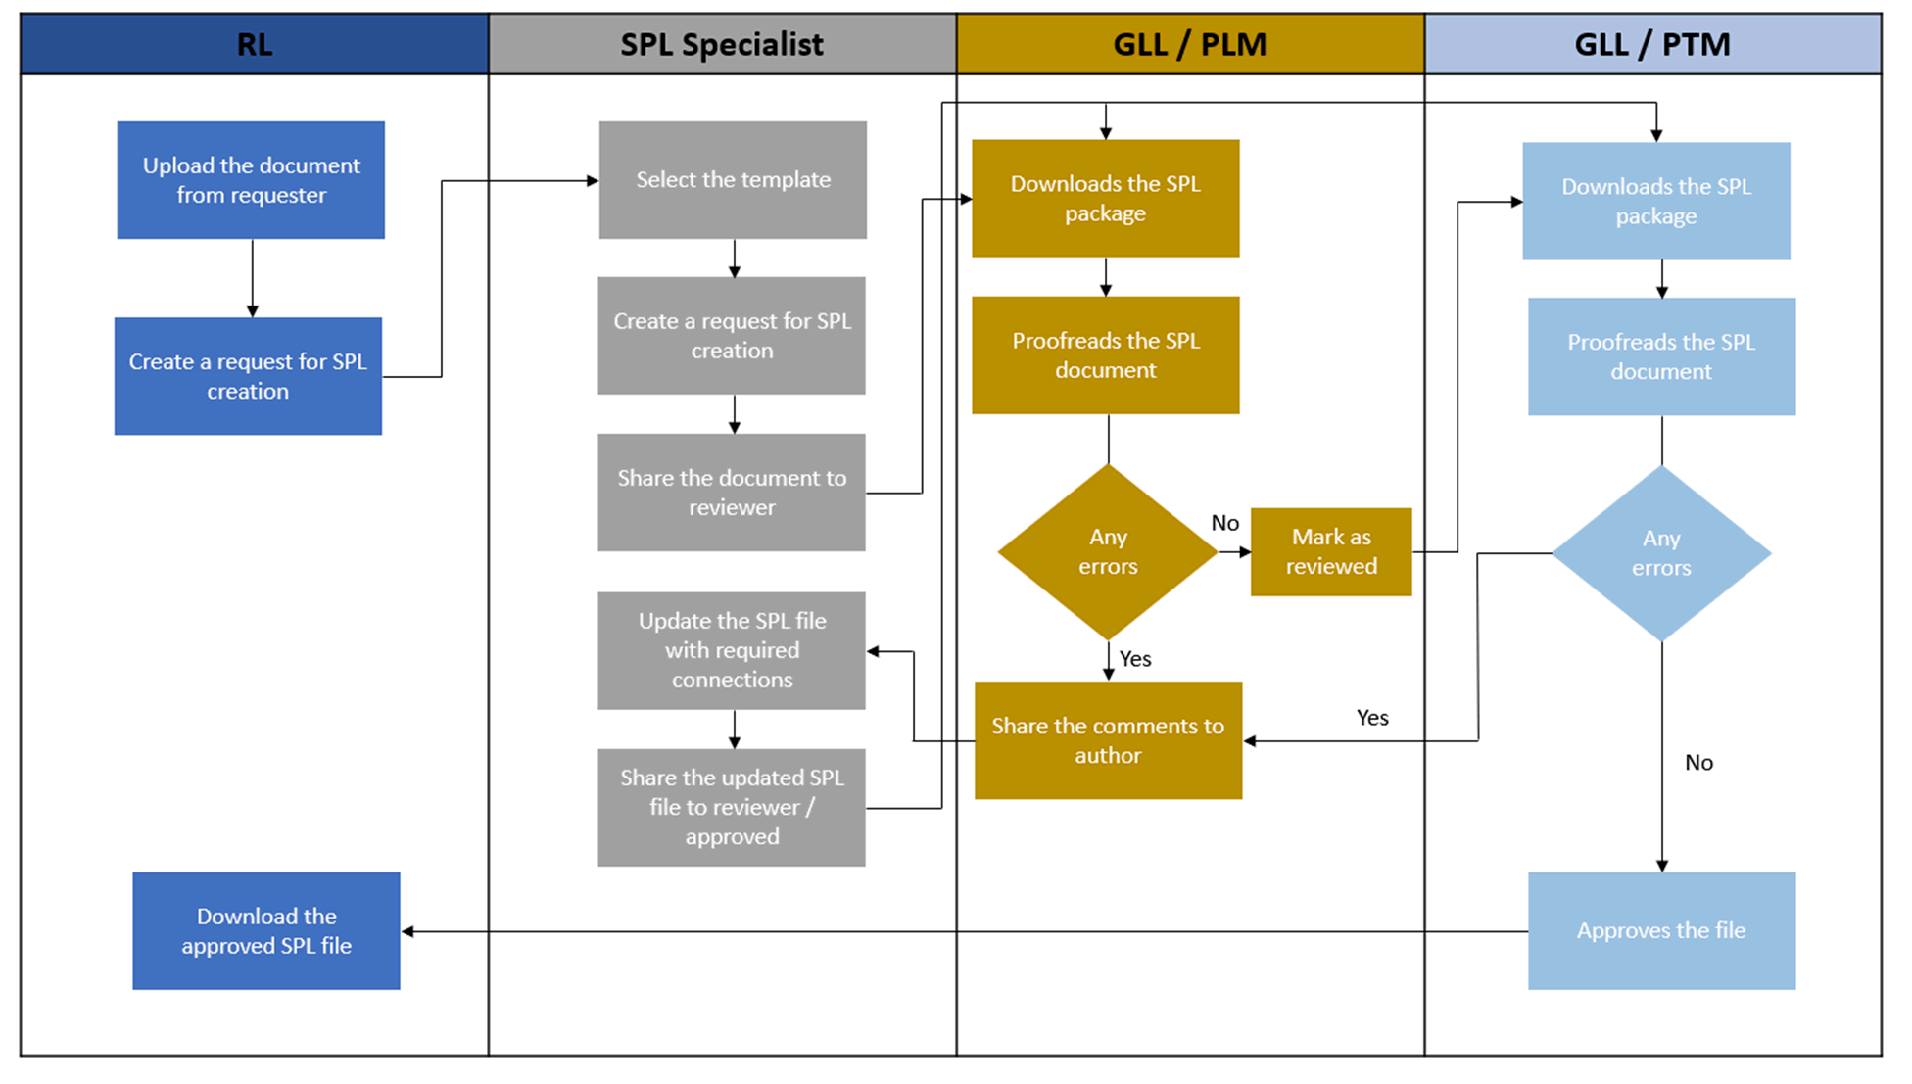

  - Appendix B: Flowchart for Revision of SPL

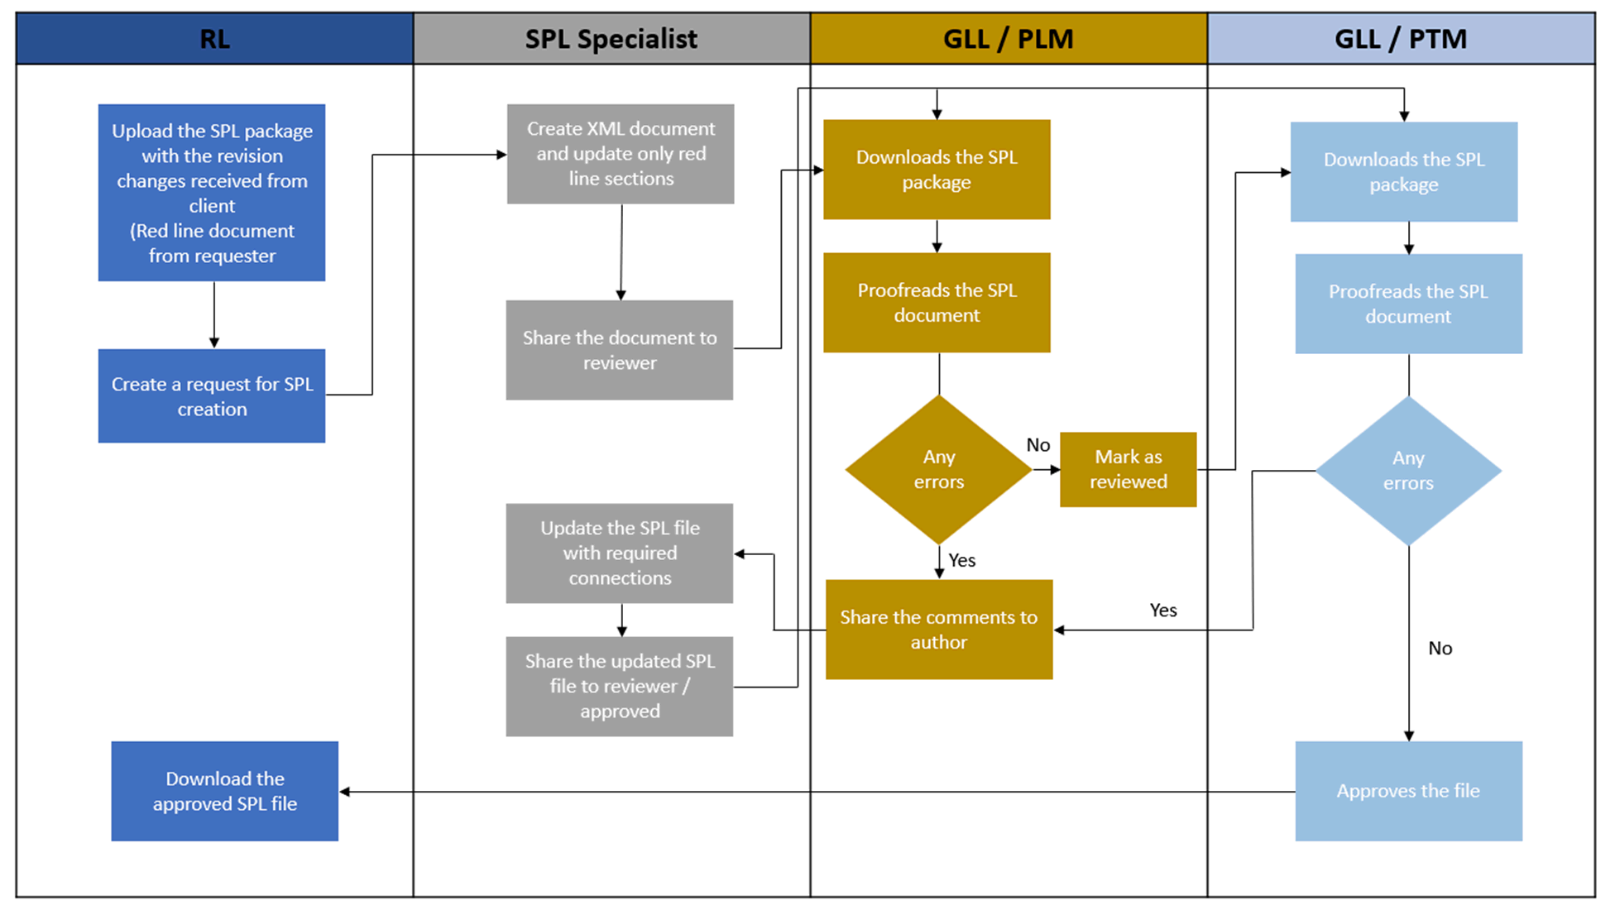

Page 11 of 11
Copyright © 2023, IQVIA. All rights reserved. The contents of this document are confidential and proprietary to IQVIA Holdings Inc. and its subsidiaries. Unauthorized use, disclosure or reproduction is strictly prohibited.

UserName: Glizer, Veronica (q735279) Title:
Date: Tuesday, 07 February 2023, 07:34 AM Eastern Time Meaning: Signing this Document Indicates My Approval
================================================

UserName: NAJI, Kenza (u1090913) Title:
Date: Tuesday, 07 February 2023, 08:45 AM Eastern Time Meaning: Signing this Document Indicates My Approval
================================================

UserName: Schreiber, Cindy (q831321) Title:
Date: Tuesday, 07 February 2023, 08:49 AM Eastern Time Meaning: Signing this Document Indicates My Approval
================================================

UserName: Schreiber, Cindy (q831321) Title:
Date: Tuesday, 07 February 2023, 08:52 AM Eastern Time Meaning: Signing this Document Indicates My Approval
================================================

UserName: Kemp, Jaco (q608126) Title:
Date: Tuesday, 07 February 2023, 09:55 AM Eastern Time Meaning: Signing this Document Indicates My Approval
================================================

UserName: Singh, Priti (q823374) Title:
Date: Tuesday, 07 February 2023, 11:21 AM Eastern Time Meaning: Signing this Document Indicates My Approval
================================================

UserName: Krecsak, Laszlo (q812064) Title:
Date: Wednesday, 08 February 2023, 03:09 AM Eastern Time Meaning: Signing this Document Indicates My Approval
================================================

